The Iron Man – Robot Revolution
Year 3 Scheme of Work
Week 1: Poetry
Photocopy Masters

Week 1 Day 1 Reading Comprehension 20/4/20
Week 1 Day 1 Reading Comprehension ANSWERS 20/4/20
Week 1 Day 2 Extract for parent to read aloud 21/4/20
Week 1 Day 2 Verbs Extension work 21/4/20
Week 1 Day 3 Question Activity 22/4/20
Week 1 Day 3 Similes 22/4/20
Week 1 Day 4 Big Write Template (colour) 23/4/20
Week 1 Day 4 Success Criteria 23/4/20

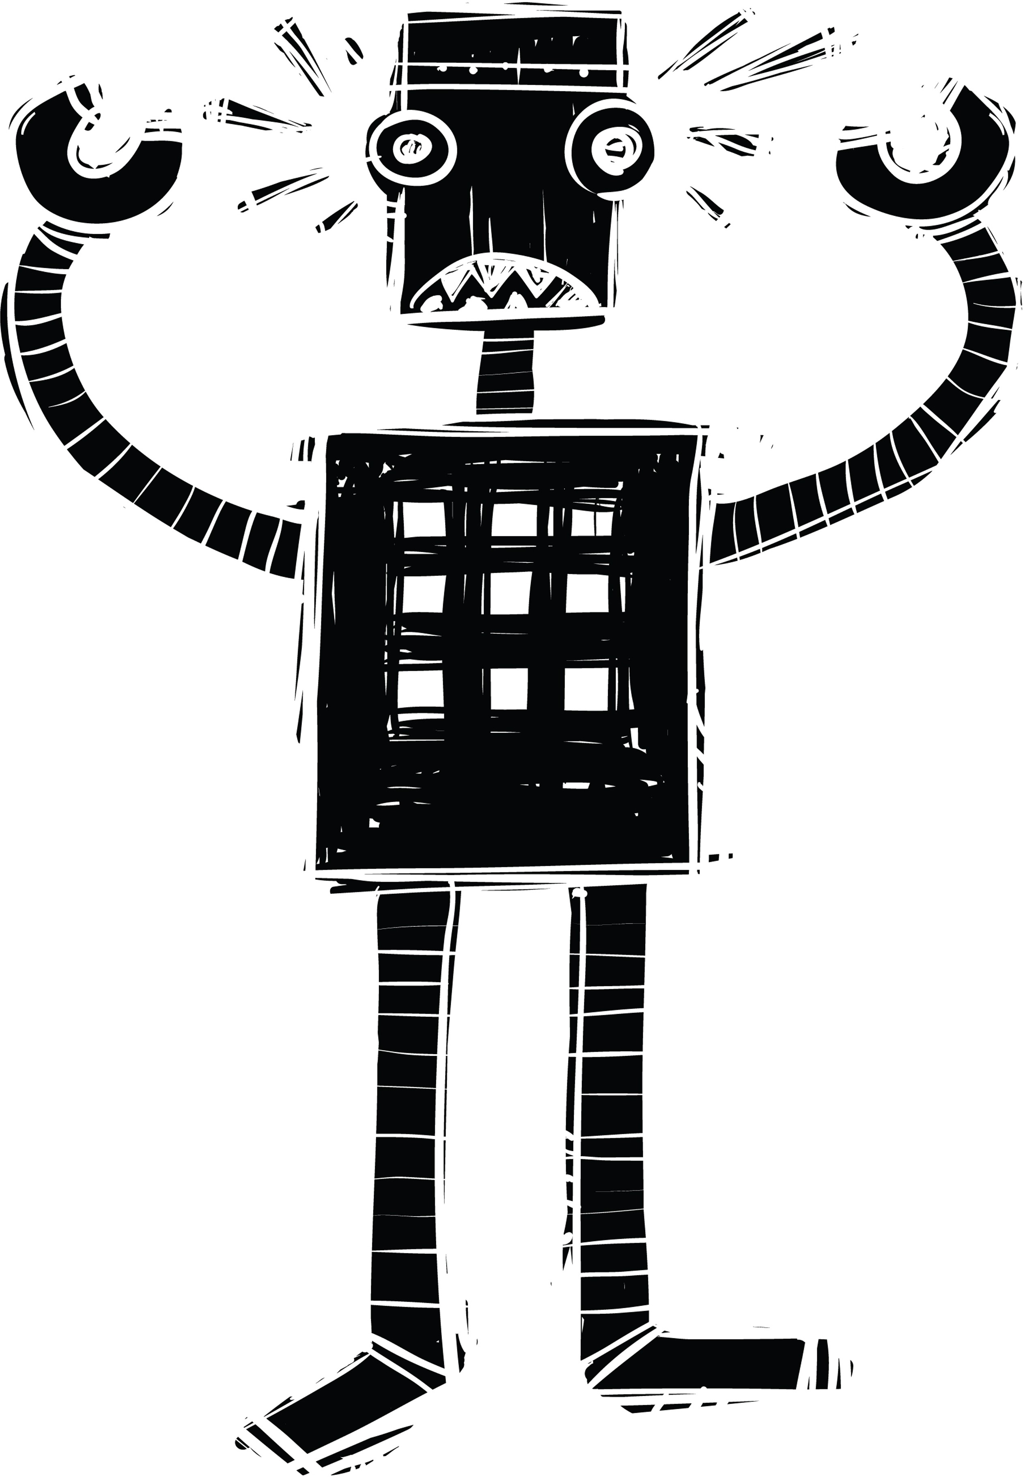

Learning Objective: I can answer questions about what I have read 20/4

The Coming of the Iron Man

The Iron Man came to the top of the cliff.
How far had he walked? Nobody knows. Where did he come from? Nobody knows. How was he made? Nobody knows.
Taller than a house, the Iron Man stood at the top of the cliff, on the very brink, in the darkness.
The wind sang through his iron fingers. His great iron head, shaped like a dustbin but as big as a bedroom, slowly turned to the right, slowly turned to the left. His iron ears turned, this way, that way. He was hearing the sea. His eyes, like headlamps, glowed white, then red, then infrared, searching the sea. Never before had the Iron Man seen the sea.
He swayed in the strong wind that pressed against his back. He swayed forward, on the brink of the high cliff.
And his right foot, his enormous iron right foot, lifted - up, out into space, and the Iron Man stepped forward, off the cliff, into nothingness.
CRRRAAAASSSSSSH!
Use the text to fill in the missing words and answer the questions.

- The Iron Man came to the top of the .
- The Iron Man was taller than a .
- The Iron Man’s was shaped like a dustbin.
- The Iron Man could the sea.
- The strong pressed against his back.
- The Iron Man’s was enormous.
- The Iron Man forward off the cliff.

- What does Ted Hughes use in the first paragraph to grab the reader's attention?

______________________________________________________________________

- What words tell us that the Iron Man is bigger than a person?

- What are the Iron Man’s eyes like?

- What word tells us that it is night time?

- How does the Iron Man’s head move?

- What did the Iron Man step into?

________________________________________________________________________________________________________

- Why does Ted Hughes use questions in the first paragraph?

- What was the weather like?

- What do you think the word ‘brink’ means?

- Which word describes the size of the Iron Man's foot?

- Had the Iron Man ever seen the sea before?

- Why do you think the Iron Man stepped off the cliff?

______________________________________________________________________

Week 1 Day 1: Reading Comprehension Answer Sheet
FOR PARENT USE ONLY 20th April 2020

Use the text to fill in the missing words.
- The Iron Man came to the top of the cliff.
- The Iron Man was taller than a house.
- The Iron Man’s head was shaped like a dustbin.
- The Iron Man could see the sea.
- The strong wind pressed against his back.
- The Iron Man’s right foot was enormous.
- The Iron Man stepped forward off the cliff.

Use the beginning of the story to help you answer the questions.
- What does Ted Hughes use in the first paragraph to grab the reader's attention? He uses questions to grab the readers’ attention.
- What words tell us that the Iron Man is bigger than a person?
‘Taller than a house’.

What are the Iron Man’s eyes like? Headlamps.
- What word tells us that it is night time? ‘Darkness’.
- How does the Iron Man’s head move? ‘Slowly left and right’.
- What did the Iron Man step into? ‘Nothingness’.

Use the beginning of the story to help you answer the questions.
- Why does Ted Hughes use questions in the first paragraph? To grab the readers’ attention.
- What was the weather like? Windy.
- What do you think the word ‘brink’ means? On the very edge of something.
- Which word describes the size of the Iron Man's foot? “Enormous’.
- Had the Iron Man ever seen the sea before? No.
- Why do you think the Iron Man stepped off the cliff? Because he didn’t know that he would fall.

Extract for Parent to read aloud.
Week 1 Day 2 TUESDAY 21st April

THE IRON MAN
Ted Hughes

1
The Coming of the Iron Man

The Iron Man came to the top of the cliff.
How far had he walked? Nobody knows. Where did he come from? Nobody knows. How was he made? Nobody knows.
Taller than a house, the Iron Man stood at the top of the cliff, on the very brink, in the darkness.
The wind sang through his iron fingers. His great iron head, shaped like a dustbin but as big as a bedroom, slowly turned to the right, slowly turned to the left. His iron ears turned, this way, that way. He was hearing the sea. His eyes, like headlamps, glowed white, then red, then infrared, searching the sea.
Never before had the Iron Man seen the sea.
He swayed in the strong wind that pressed against his back. He swayed forward, on the brink of the high cliff.
And his right foot, his enormous iron right foot, lifted - up, out into space, and the Iron Man stepped forward, off the cliff, into nothingness.
CRRRAAAASSSSSSH!
Down the cliff the Iron Man came toppling, head over heels. CRASH!
CRASH!
CRASH!
From rock to rock, snag to snag, tumbling slowly. And as he crashed and crashed and crashed. His iron legs fell off.
His iron arms broke off, and the hands broke off the arms. His great iron ears fell off and his eyes fell out.
His great iron head fell off.
All the separate pieces tumbled, scattered, crashing, bumping, clanging, down on to the rocky beach far below.
A few rocks tumbled with him. Then
Silence.

Powerful verbs
Verbs are doing, action or being words.
Help!
Somebody has stolen all of the powerful verbs and replaced them with boring ones!
Which words will make these sentences more interesting?
blazed; turned; pressed; whistled; swayed; glowed

  - The wind went through his iron fingers.
The wind through his iron fingers.

  - His great iron head slowly went to the left.
His great iron head slowly to the left.

  - His eyes, like headlamps, went white, then went red.
His eyes, like headlamps, …………………… white, then red.

  - He moved in the strong wind that went against his back.
He …………………… in the strong wind that against his back.

wheeling; crashing; waved; splashing; tugging
  - One of the Iron Man’s hands moved its fingers, like a crab on its back.
One of the Iron Man’s hands its fingers, like a crab on its back.

  - The stars went on moving through the sky.
The stars went on through the sky.

  - The wind went on blowing at the grass on the cliff-top.
The wind went on at the grass on the cliff-top.

  - The sea went on moving and moving.
The sea went on …………………….and ……………………..

spouted; blew; glided; covered; blazed

  - The gulls went down low over the great iron head.
The gulls down low over the great iron head.

  - The eyes went red, level with the wave tops.
The eyes red, level with the wave tops.

  - A big wave went over them and foam went over the top of the head.
A big wave ……………………… them and foam over the top of the head.

L.O. I can ask questions about a character. Wednesday 22nd April

Some of these questions we know the answer to, some we don’t. Copy each question into the correct column.

What is he made of? Where did he come from? Where is he going?
How big were his ears? What size was he?
Can he talk?
How big was his head? Who made him?
Why had he come?
What were his eyes like? Can he see?
Where is he going?

Questions we know the answer to | Questions we want to find out

………………………………………………………………………………………………………..……………………………..
L.O. I can use similes to describe the Iron Man. Wednesday 22nd April
…………………………………………………………………………………..

…………………………………………………………………………………..

………………………………………………………………………………….

…………………………………………………………………………………

…………………………………………………………………………………..

………………………………………………………………………………….

…………………………………………………………………………………

…………………………………………………………………………………..

………………………………………………………………………………….

…………………………………………………………………………………

…………………………………………………………………………………..

………………………………………………………………………………….

…………………………………………………………………………………

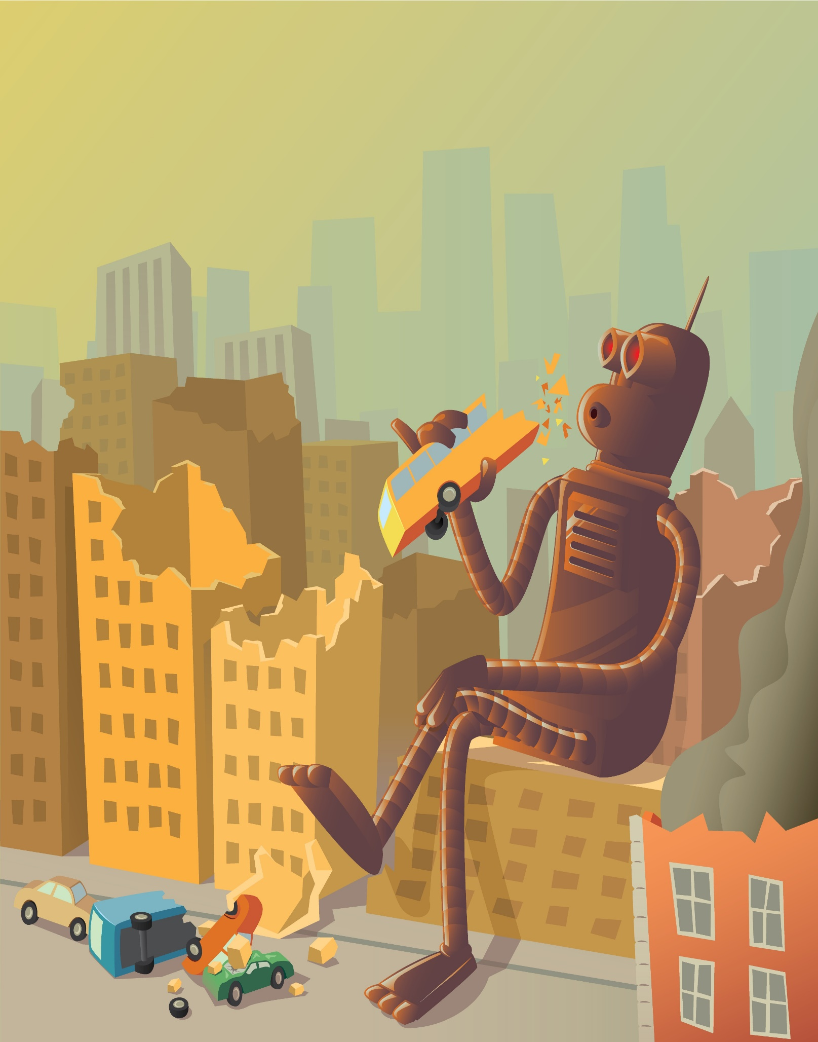
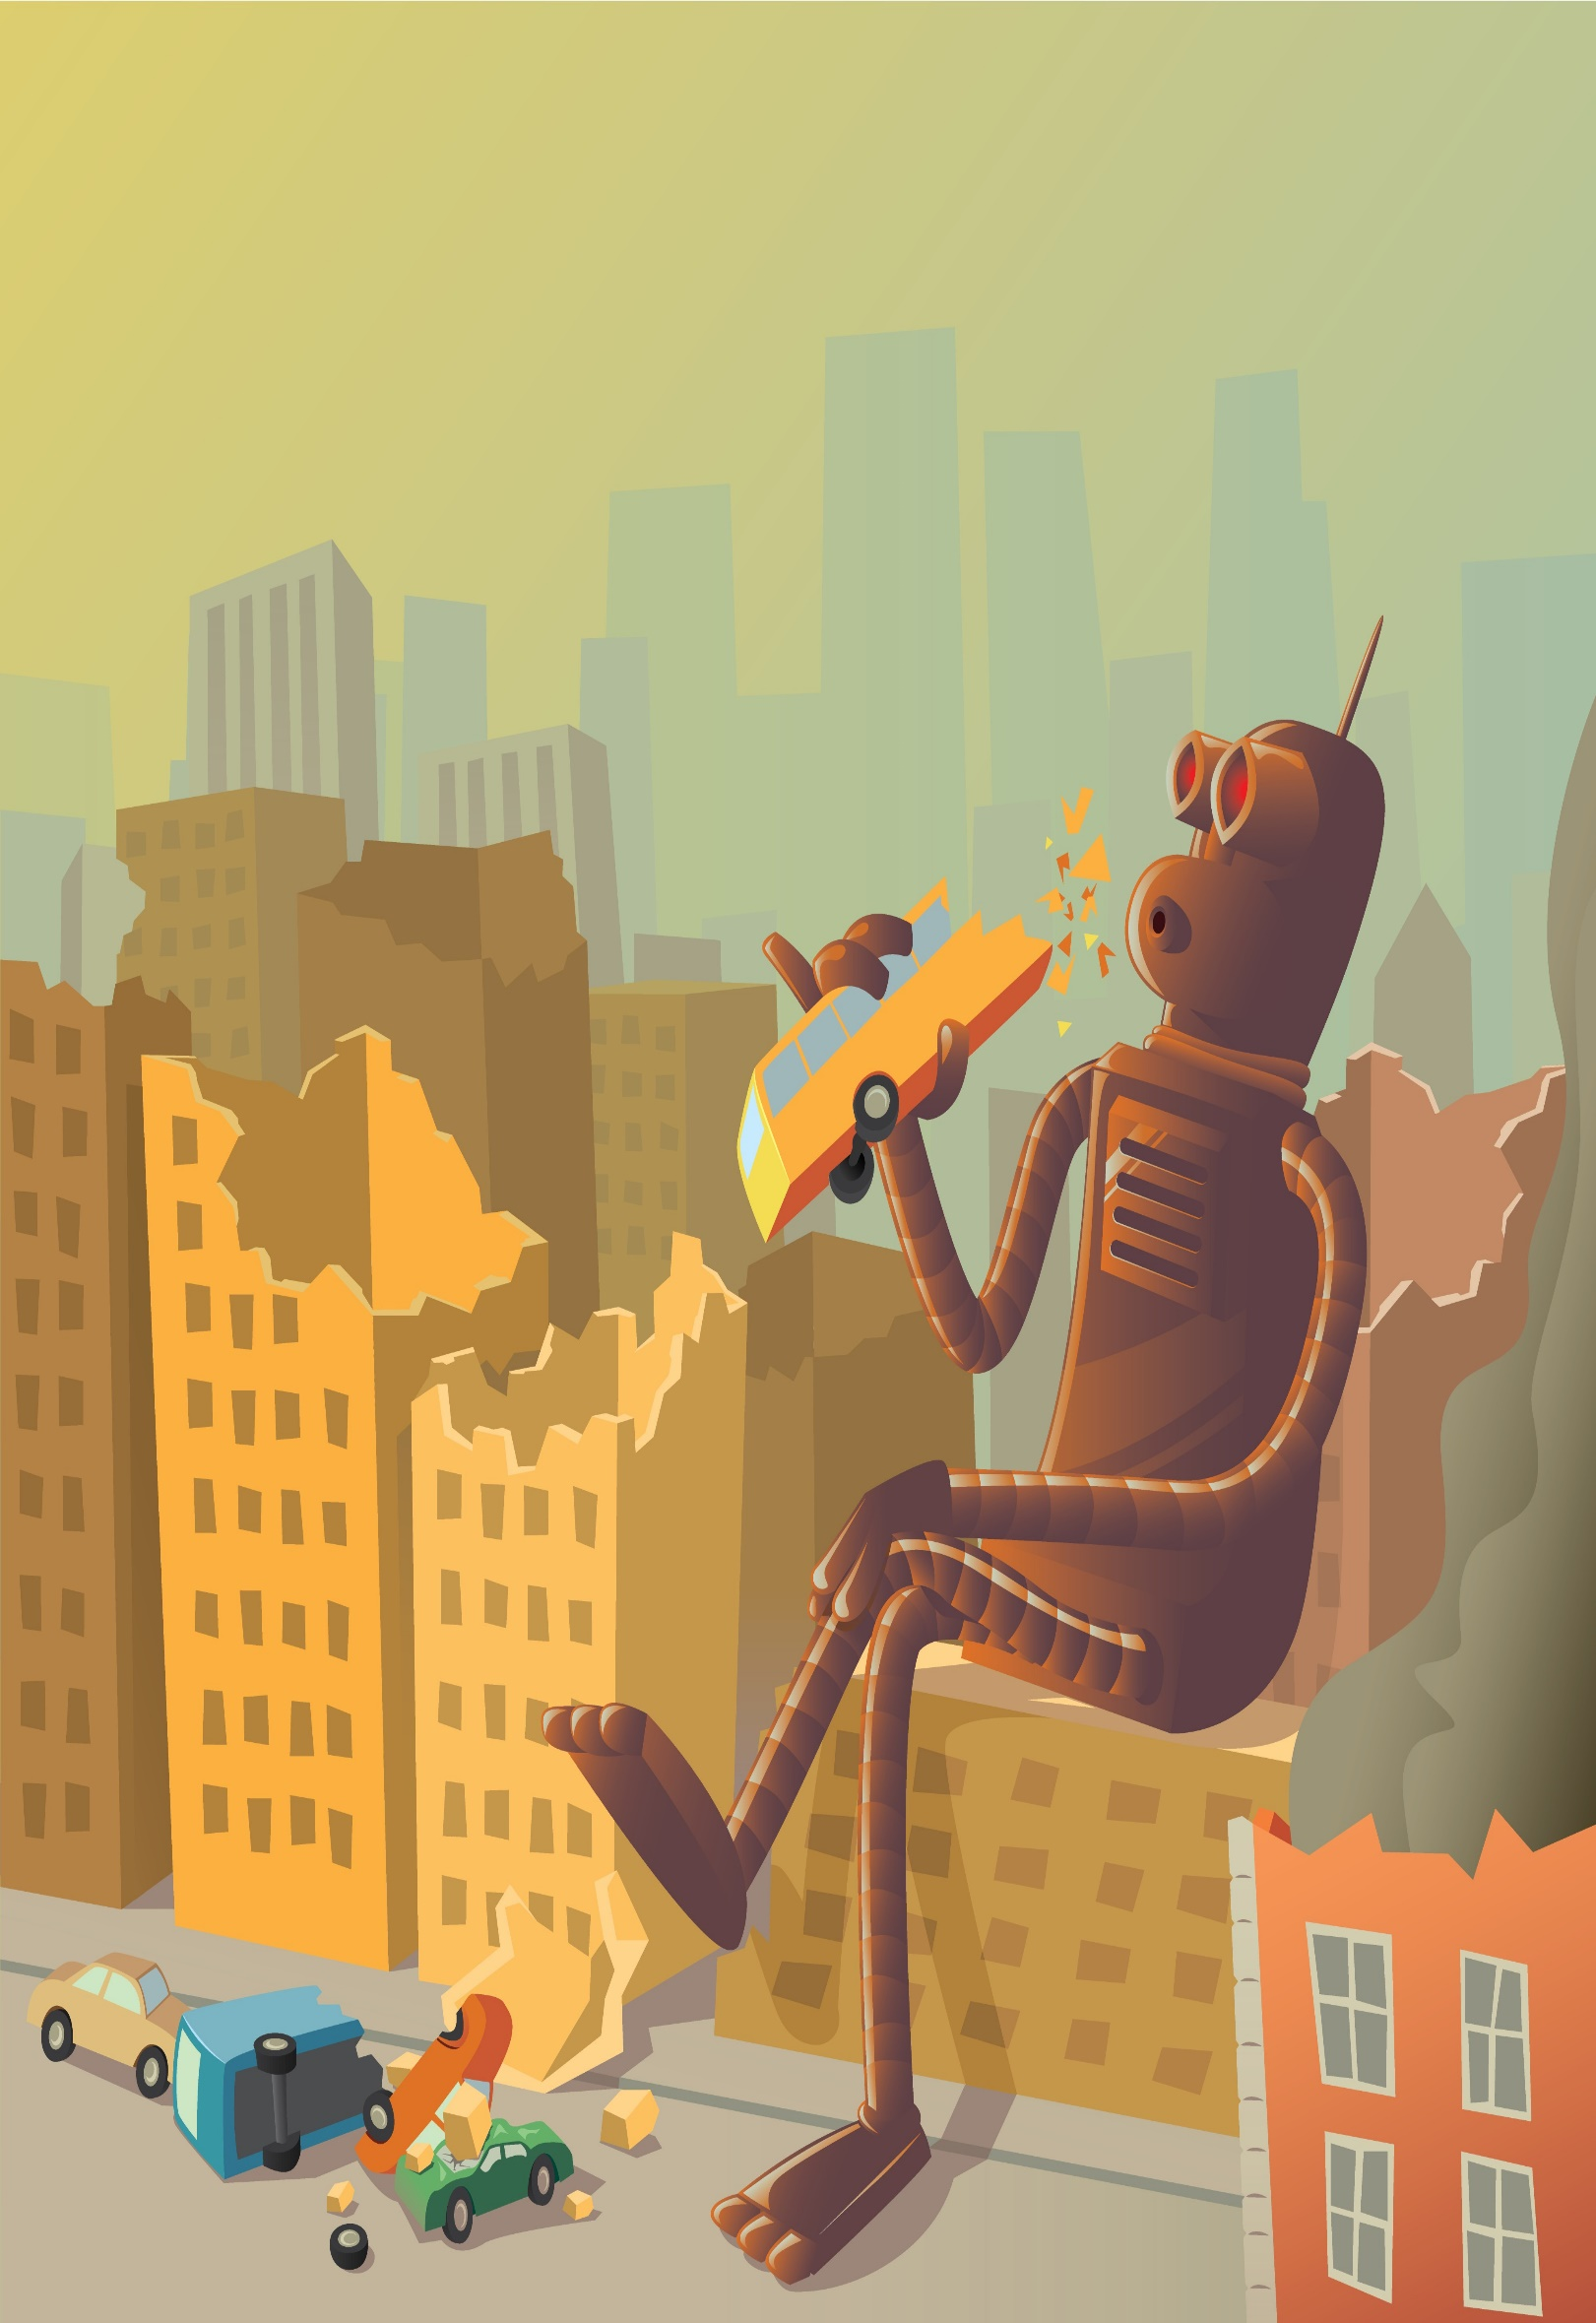
Big Write: I can write a poem about the Iron Man. 24th April 2020

…………………………………………………………………………………..

…………………………………………………………………………………..

………………………………………………………………………………….

…………………………………………………………………………………

…………………………………………………………………………………..

………………………………………………………………………………….

…………………………………………………………………………………

…………………………………………………………………………………..

………………………………………………………………………………….

…………………………………………………………………………………

…………………………………………………………………………………..

………………………………………………………………………………….

…………………………………………………………………………………

Poem
Self  assessment |  | Steps to success | Parent  assessment
 |  | 1. I have written a title
 |  | 2. Each verse has 3 lines
 |  | 3. I have used interesting words
 |  | 4. The first line is a simile
 |  | 5. The second line is a question
 |  | 6. The third line is a repeated line
 |  | 7. I have written 4 verses
8. I have left a line between each
verse.

