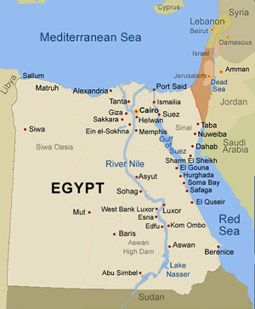

Interesting Facts about the River Nile:
The Nile River is the longest river in the world.
The Nile flows into the Mediterranean Sea.
The largest source of the Nile is Lake Victoria.

Where is the River Nile?
The River Nile is in Africa. It originates in Burundi, south of the equator, and flows northward through northeastern Africa, eventually flowing through Egypt and finally draining into the Mediterranean Sea.

Where is the source of the River Nile?
Lake Victoria, Africa's biggest lake, is generally thought of as the source of the River Nile.

Why did the Ancient Egyptians live near the River Nile?
Most Egyptians lived near the Nile as it provided water, food, transportation and excellent soil for growing food.

Why was the Nile River so important to the Ancient Egyptians?
Ancient Egypt could not have existed without the river Nile. Since rainfall is almost non-existent in Egypt, the floods provided the only source of moisture to sustain crops.

What else did the Nile provide for the Ancient Egyptians?
Reeds, called papyrus, grew along side the Nile. The Egyptians made paper and boats from the reeds.
Find out about Egyptian Writing
The Nile also gave the ancient Egyptians food. They used spears and nets to catch fish. They would also use the nets to catch birds that flew close to the surface of the water.
Another way the Nile helped the ancient Egyptians was in trade. The Nile was the quickest and easiest way to travel from place to place.

What was the area next to the River Nile called?
This area was known as the Black Land. Further away from the river was the Red Land, a region of inhospitable desert.

When did the Nile flood?
The River Nile flooded every year between June and September, in a season the Egyptians called akhet - the inundation.

Who was the Nile God?
Hapi was the Nile god. Honouring a god was very important, so when a flood came the Egyptians would thank Hapi for bringing fertility to the land.

