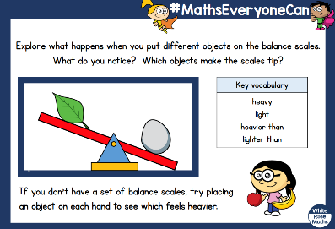
Can you draw pictures of your scale and objects?
Challenge - Can you label each side of you scale using heavy or light

