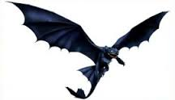
astronomers telescope gigantic slow space immense skyline Australia earthquake Switzerland Tasmania foreclaws mountains darkness monstrosity giant Space-Bat-Angel-Dragon rumbling

