Find five nouns in this picture.

1.

2.

3.

4.

5.

Find two adjectives from the part of the story that we read.

1.

2

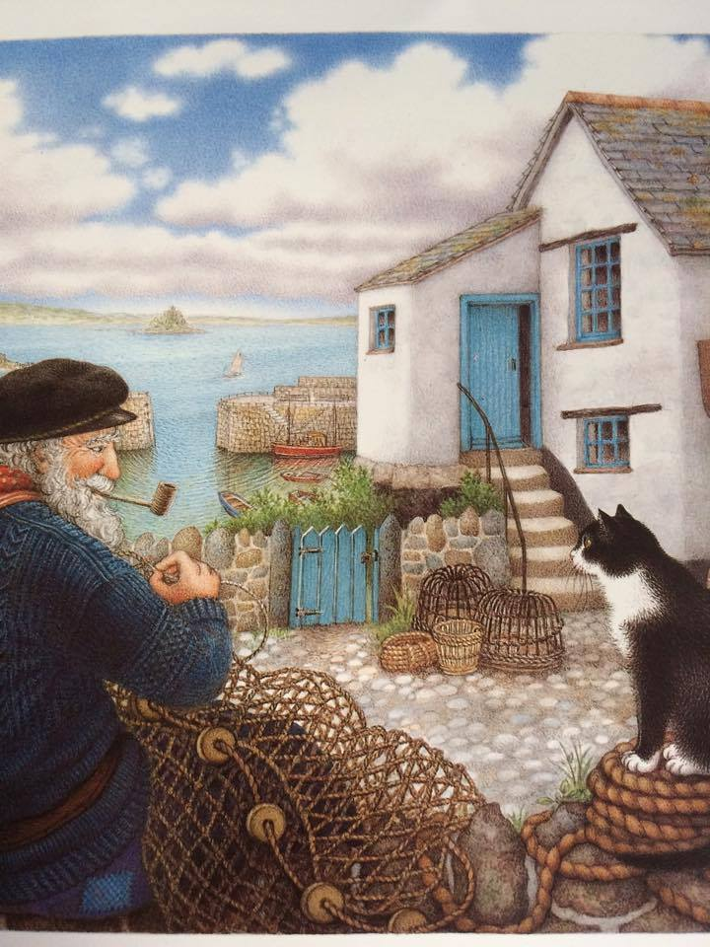

Draw a picture of the setting

Write some words which describe the setting of the story.