Recycled Robots with Artist: Clayton Bailey - Sculpture
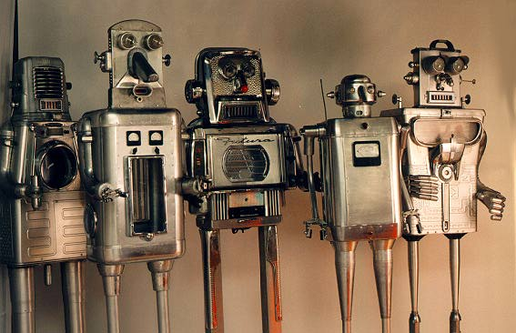
Found and reused objects- aluminum, chrome, glass, light

Artist Clayton Bailey was born in 1939 in Wisconsin in the USA.
Clayton Bailey has made approximately 100 life-size robot sculptures of found objects since 1976. He searches the local junk markets and scrap metal yards for discarded home appliances, cookware, bicycle and car parts. He carefully grafts the parts together into new forms making them into robot sculptures.
His family of robot sculptures range from the humanoid to the pet dog or exotic bird or insect. They don't walk around and break your china and endanger your art collection! They are static; they stand still and blink their lights.
For additional information: http://www.claytonbailey.com/

Can you create your own robot sculpture? Don’t forget to send me pictures if you can!

Week 1 – Collect all the parts together. What will you need to assemble your robot?
Week 2 – Assemble your robot. Evaluate your robot.

