Dear Children,

I hope you enjoyed the story I sent you about Dora’s Eggs. Yesterday, I laid 10 little eggs but I haven’t got time to look after them because I’m so busy on the farm looking after all the animals. Mr Tindall has told me all about Reception Class at Holy Family School and I’ve heard that you are all very kind, caring children. Do you think you could help to look after my eggs?

On Monday, a farmer is going to deliver the eggs to your school. They will be in a little incubator which will keep them warm until the chicks hatch. I need you to watch the eggs carefully and when the chicks hatch, you will need to feed them and give them lots of love. I will collect the chicks when they are 10 days old.
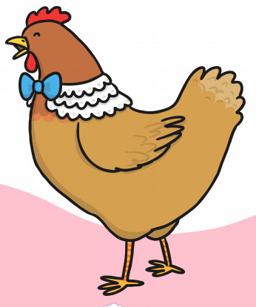
Lots of love

Mother Hen
xxx

